Press Release
Date: December 5, 2016
For Immediate Release
Major Funding Announced for Community Playgrounds
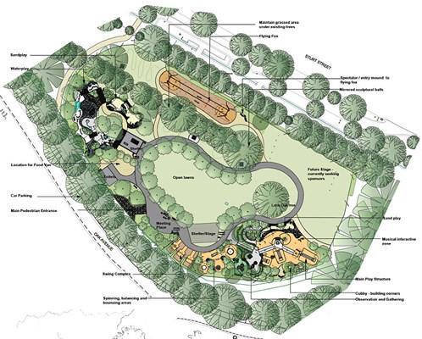
Plans to upgrade Yardley Park and Barnes Park playgrounds were unveiled today by Green Ponds Municipality Council Mayor John Nesbitt. Mayor Nesbitt announced that funding of $350,000 for the upgrade had been secured through a Commonwealth Government Grant, further adding “An extensive period of consultation had been undertaken within the community with final plans signed off at a special council meeting this morning”.
New equipment will include flying foxes, slides, swings, a water play space, tactile areas, disability accessible play equipment, shade sails, family tables, chairs and bbq’s, with extensive upgrades to existing equipment. A Grand Opening Community Fun Day is planned for Saturday January 14.
Construction has been awarded to local building company Aurenom. Project Manager, Craig Mason acknowledged community input saying, “We are thrilled to be involved in such an exciting project. Members of the local community have had a strong say into the type of equipment they would like to see and we will deliver what the community wants’.
Construction will commence on both playgrounds from Monday December 12 with both parks closed until January 14.
Proposed plan for Yardley Park.
Image courtesy Ballarat City Council
Plans can be viewed at Council Chambers in Council Street and further information can be obtained by contacting General Manager, Sue Gates on 9856 9845 or by keeping an eye on updates on the Council webpage – www.gpmc.com.au/communityplaygroundupdate

